# CS 255 System Design Document

This template lays out all the different sections that you need to complete for Project Two. Each section has guidance to prompt your thinking. You will need to continually reference the interview transcript as you work to make sure that you are addressing your client’s needs. There is no required length for the final document. Instead the goal is to complete each section based on what your client’s needs are. Remove this note when you are finished, and replace all bracketed text with the relevant information.

## UML Diagrams

### UML Use Case Diagram

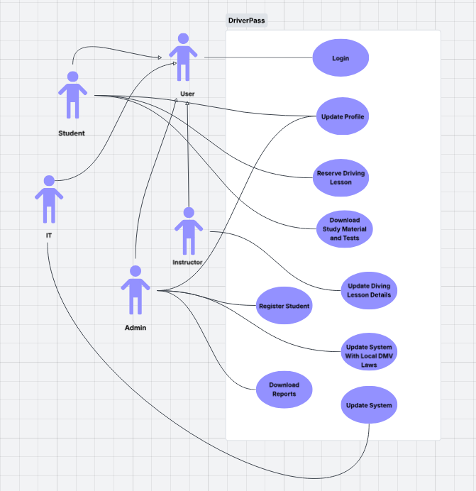

### UML Activity Diagrams

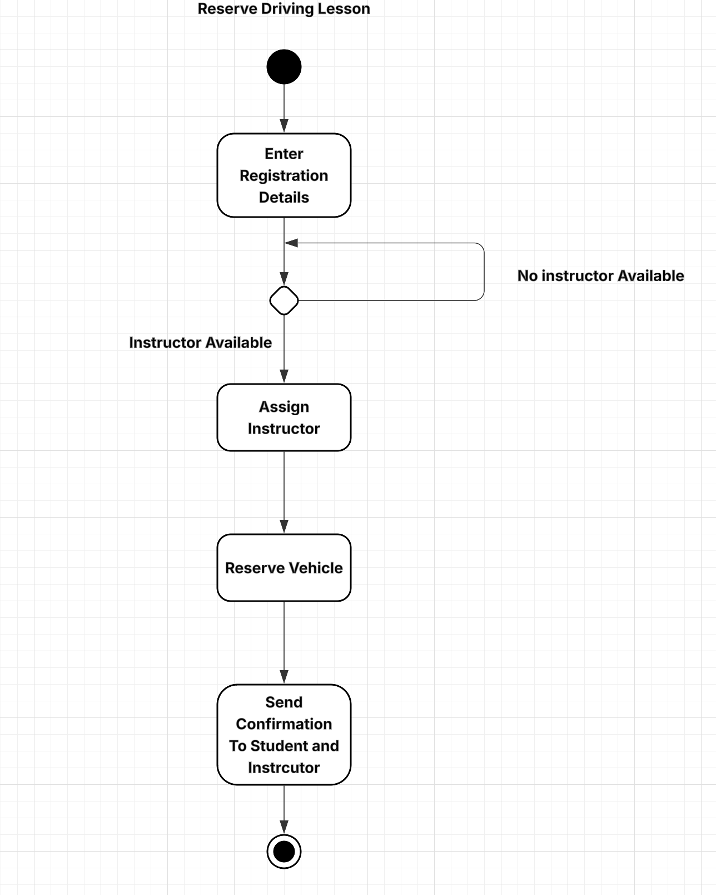

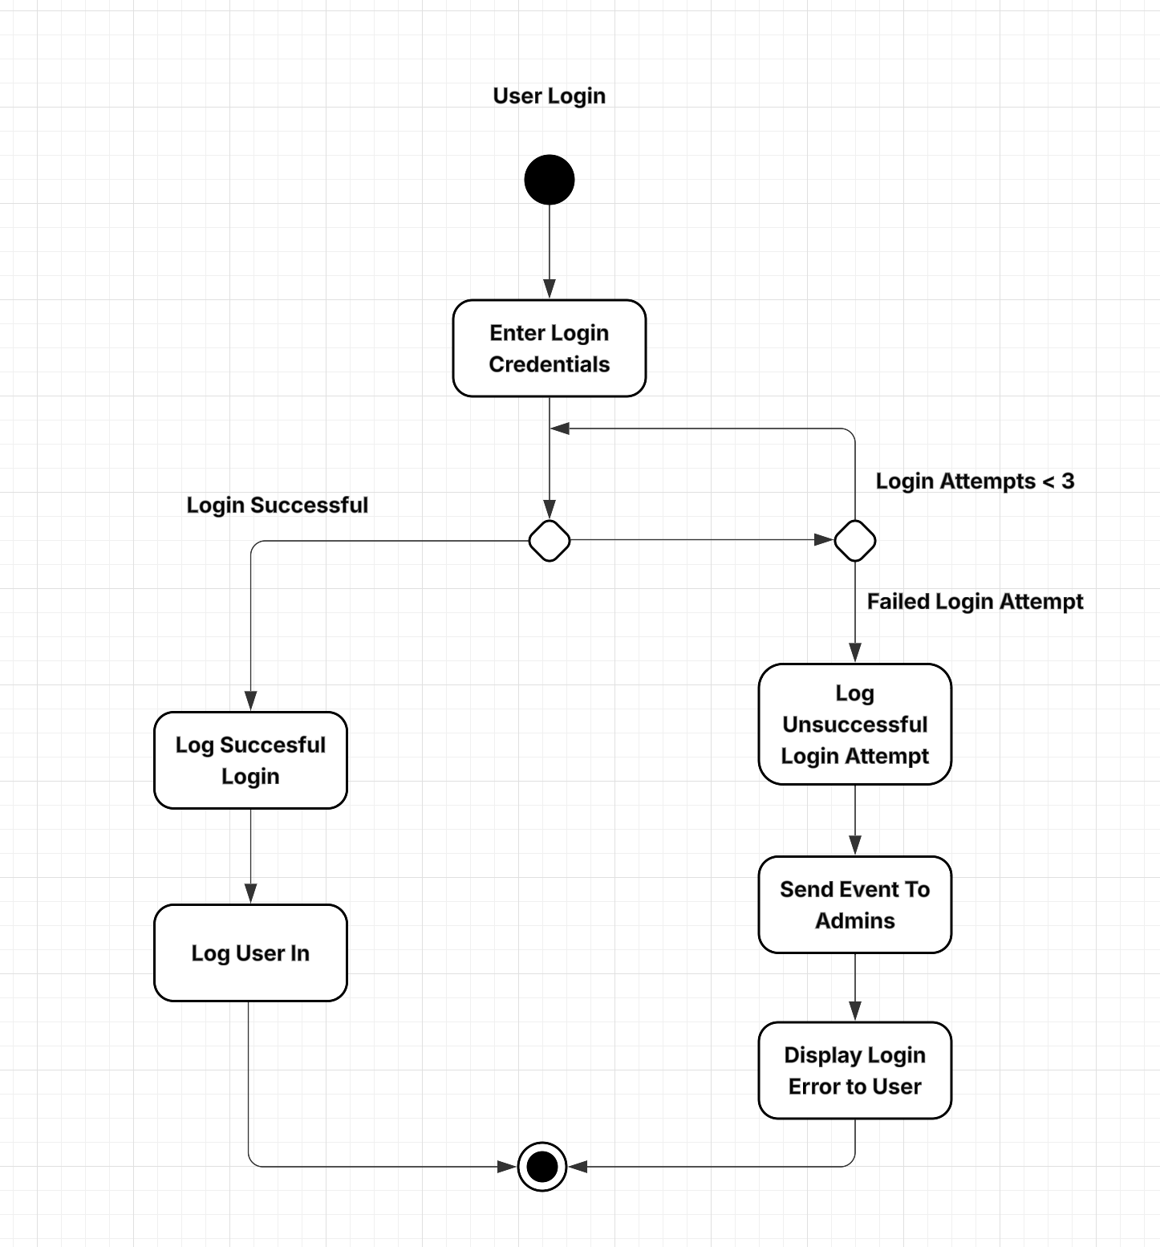

### UML Sequence Diagram

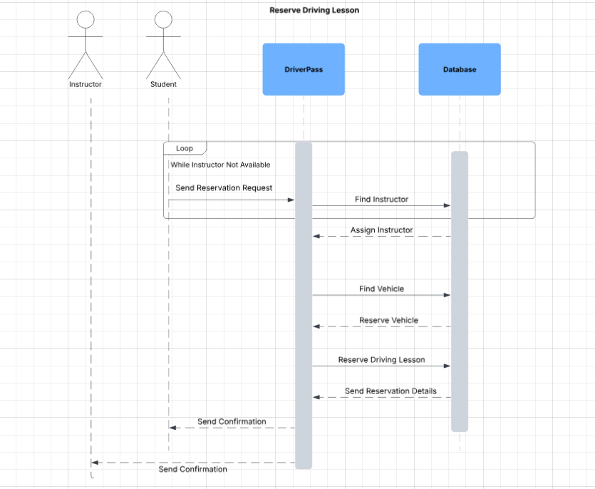

### UML Class Diagram

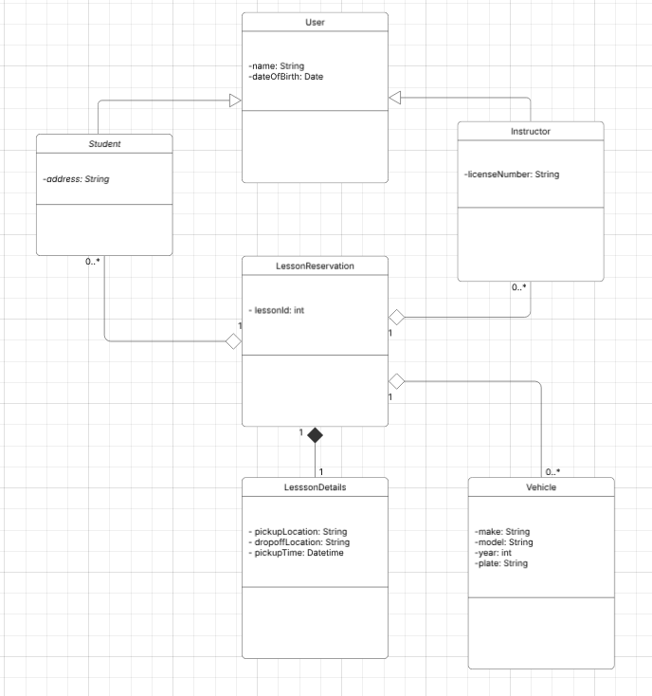

## Technical Requirements

The first crucial decision is the programming language to be used to create the DriverPass software. Java will be used since it can be used for both web and mobile applications. A relational database is necessary to store pertinent data and create the necessary relationship between different entities. MySQL will be used to achieve this. Since a serverless approach will be used to ensure availability and scalability, AWS will be used. An EC2 instance will be used for servers which will scale as needed based on traffic. This will also help with availability to maintain an up time of 99.99% and fault tolerance via load balancing of servers. The S3 service will be used in conjunction with CloudFront to create a CDN that will store and serve important files such as static images and videos. Finally, to improve performance, caching will be implemented using Redis will be used for caching to avoid redundant requests for resources.